Exercise: Loops
Test your tasks in the Judge system: https://judge.softuni.org/Contests/4412

For Loop

Power of Number
Write a program to calculate number raising to a certain power:
- Reads an integer number n from the console
- Reads an integer number p which represents power from the console
- Print the result of n to the power of p
Note: Don't use Math.Pow(), use loops

Example
Input | Output |  | Input | Output |  | Input | Output
2  5 | 32 |  | 3  4 | 81 |  | 2  3 | 8

Multiplication Table
Write a program that prints a multiplication table:
- Reads an integer number n from the console
- Print a multiplication table of size 10 for given integer n in the following format:
"{n} x {i} = {result}" for each i in the range [1…10]

Example
Input | Output |  | Input | Output |  | Input | Output
2 | 2 x 1 = 2  2 x 2 = 4  2 x 3 = 6  2 x 4 = 8  2 x 5 = 10  2 x 6 = 12  2 x 7 = 14  2 x 8 = 16  2 x 9 = 18  2 x 10 = 20 |  | 3 | 3 x 1 = 3  3 x 2 = 6  3 x 3 = 9  3 x 4 = 12  3 x 5 = 15  3 x 6 = 18  3 x 7 = 21  3 x 8 = 24  3 x 9 = 27  3 x 10 = 30 |  | 5 | 5 x 1 = 5  5 x 2 = 10  5 x 3 = 15  5 x 4 = 20  5 x 5 = 25  5 x 6 = 30  5 x 7 = 35  5 x 8 = 40  5 x 9 = 45  5 x 10 = 50

Biggest Number
Write a program to find the biggest among given n numbers:
- Read an integer number n (the amount of input numbers) and n integer numbers from the console
- Find and print the biggest number

Example
Input | Output |  | Input | Output |  | Input | Output
3  40  90  50 | 90 |  | 4  -40  -3  -90  -50 | -3 |  | 2  1  7 | 7

Vowel Sum
Write a program to sum N vowels, according to the table below:
- Read an integer number N: the count of characters
- Read N characters and for each vowel character adds its value from the table to the result
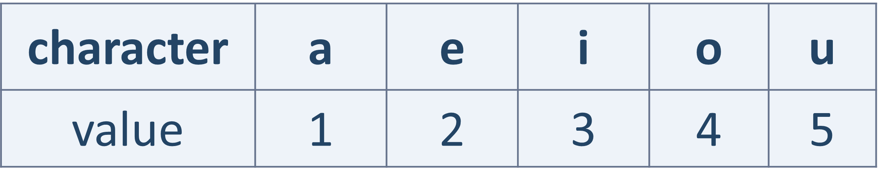

Example
Input | Output |  | Input | Output |  | Input | Output
2  a  e | 3 |  | 3  i  x  u | 8 |  | 3  o  g  a | 5

Division to 2, 3 and 4
Write a program to find statistics about division to 2, 3 and 4:
- Read an integer number N and N integers from the console
- Find in percentages how many of these integers can divide without a remainder to numbers 2, 3 and 4
- Print the percentages, formatted to the second decimal digit:
  - On the first line print percent of the numbers that are divisible by 2
  - On the first line print percent of the numbers that are divisible by 3
  - On the first line print percent of the numbers that are divisible by 4

Example
Input | Output |  | Input | Output
3  3  6  9 | 33.33%  100.00%  0.00% |  | 3  4  6  3 | 66.67%  66.67%  33.33%

While Loop

Special Number
Write a program to check if given number is special:
  - Special numbers are divisible by all of their digits without remainder
  - Reads an integer number and check whether it is a special number
  - If the number IS special print: "{num} is special"
  - If the number is NOT special print: "{num} is not special"
Note: There will not be numbers with digit 0 in them.

Example
Input | Output |  | Input | Output
23 | 23 is not special |  | 212 | 212 is special

Special Bonus
Write a program to apply a 20% bonus for certain number:
  - Reads an integer number from the console: the "stop number"
  - Keep reading integers until it finds the stop number
  - When the stop number is found, increase the value of the previous number before it with 20% and print it

Example
Input | Output |  | Input | Output
25  20  30  25 | 36 |  | 14  6  10  14 | 12

Account Balance
Write a program to calculate an account balance:
  - Read a sequence of incomes / expenses, until "End" is read
  - Add the money to the balance (starting form 0)
  - Print "Increase: {money}" or "Decrease: {money}", where value is formatted to the second decimal digit
  - Finally, print the account balance, formatted to the second decimal digit in the following format: "Balance: {account balance}"

Example
Input | Output |  | Input | Output
500  15.5  -80.35  End | Increase: 500.00  Increase: 15.50  Decrease: 80.35  Balance: 435.15 |  | 200  300  -100  End | Increase: 200.00  Increase: 300.00  Decrease: 100.00  Balance: 400.00

